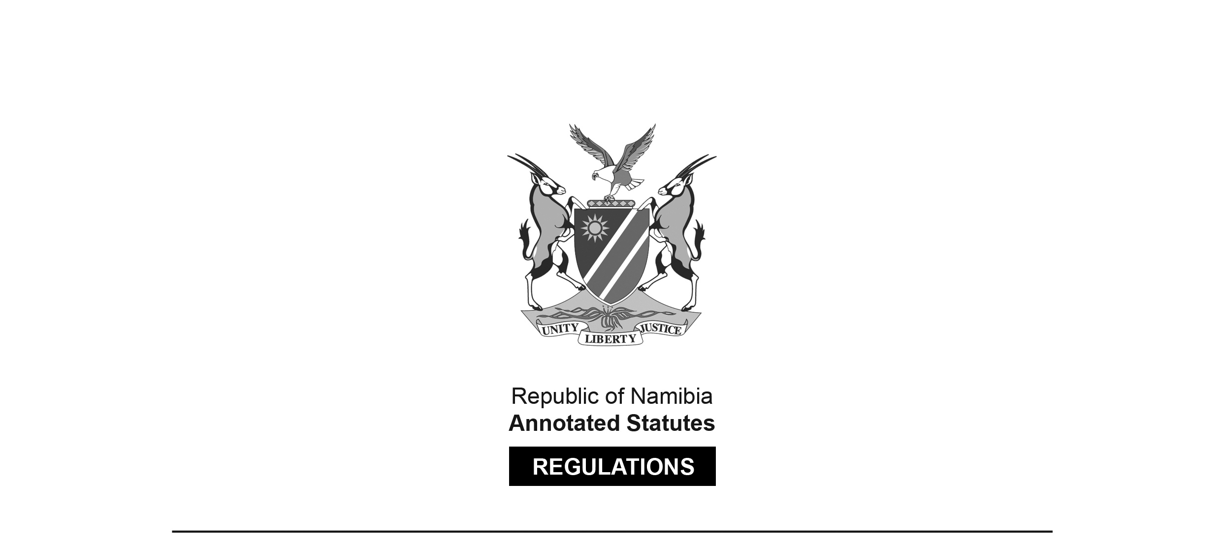
REGULATIONS MADE IN TERMS OF

Public Office-Bearers (Remuneration and Benefits) Commission Act 3 of 2005
section 11

Regulations relating to Transport Benefits
for Public Office-Bearers
Proclamation 12 of 2021
(GG 7476)
came into force on date of publication: 4 March 2021

as amended by

Proclamation 12 of 2022 (GG 7805)
came into force on date of publication: 13 May 2022

The Government Notices which publish the original regulations and the amendment to the regulations both note that they were made after consultation with the Minister responsible for finance and the Public Office-Bearers (Remuneration and Benefits) Commission.

ARRANGEMENT OF REGULATIONS

1. Definitions
2. Application of regulations
3. Off-road motor vehicles allocated to designated public office-bearers
4. Sedan motor vehicles allocated to designated public office-bearers
5. Compliance and enforcement
6. Relief motor vehicles

ANNEXURE: Designated Public Office-Bearers

Definitions

1. In these regulations, a word or an expression to which a meaning has been assigned in the Act has that meaning and unless the context otherwise indicates -

“designated public office-bearer” means a public office-bearer referred to in regulation 2;

“Ministry” means the Ministry administering matters relating to transport;

“motor vehicle” means a motor vehicle as defined in section 1 of the Road Traffic Act, 1999 (Act No. 22 of 1999); and

“the Act” means the Public Office-Bearers (Remuneration and Benefits) Commission Act, 2005 (Act No. 3 of 2005).

Application of regulations

2. These regulations apply to all designated public office-bearers, specified in the Annexure, who are allocated official government motor vehicles.

Off-road motor vehicles allocated to designated public office-bearers

3. (1) One off-road motor vehicle must be allocated to each -

(a) government office, ministry or agency; and

(b) an institution occupied by a designated public office-bearer other than an institution referred to in paragraph (a),

for official use by the designated public office-bearer, or designated public office-bearers, allocated to that office, ministry, agency or institution.

(2) The off-road motor vehicle allocated in terms of subregulation (1) must only be used in an area that is not suitable for, or accessible by, a sedan motor vehicle allocated to the designated public office-bearer in terms of regulation 4.

(3) When the need for official travel by a designated public office-bearer arises, the designated public office-bearer must present the programme of official work to the accounting officer of the respective -

(a) office, ministry or agency; or

(b) institution referred to in subregulation (1)(b),

for logistical and planning purposes.

(4) The accounting officer referred to in subregulation (3) is responsible for -

(a) booking out the off-road motor vehicle for the designated public office-bearer; and

(b) keeping monthly records in respect of the allocated off-road motor vehicle which records must include, but are not limited to, the kilometres travelled and fuel usage by the designated public office-bearer.

(5) Monthly fuel usage in respect of the off-road motor vehicle must be limited to 160 litres times four tanks amounting to a total of 640 litres per month per allocated off-road motor vehicle, inclusive of the reserve fuel tank.

(6) For the purpose of these regulations, any monthly fuel not utilised for that respective month may not be carried over to any other month.

Sedan motor vehicles allocated to designated public office-bearers

4. (1) One sedan motor vehicle must be allocated to each designated public office-bearer for official and private use.

(2) Monthly fuel usage in respect of the sedan motor vehicle must be limited to 70 litres times six tanks amounting to a total of 420 litres per month per allocated sedan motor vehicle.

(3) For the purpose of these regulations, any monthly fuel not utilised for that respective month may not be carried over to any other month.

Compliance and enforcement

5. (1) The Ministry and the accounting officers in the offices, ministries or agencies or institutions referred to in regulation 3(1) are responsible for the implementation of these regulations.

(2) The Ministry must put in place administrative measures necessary to achieve the objects of these regulations, including but not limited to, the issuance of a log sheet for purposes of recording fuel usage, travel and related information.

(3) If a designated public office-bearer contravenes or fails to comply with these regulations, the accounting officer in the office, ministry or agency or an institution referred to in regulation 3(1) must request the designated public office-bearer to, in writing, furnish the accounting officer of the Ministry with an explanation of the designated public office-bearer’s contravention or failure to comply with these regulations.

(4) If the accounting officer of the Ministry is not satisfied with the explanation given by the designated public office-bearer, the accounting officer of the Ministry must take measures against the designated public office-bearer in line with the State Finance Act, 1991 (State Finance Act No. 31 of 1991) to recover losses or damages from the designated public office-bearer.

(5) If the designated public office-bearer referred to in subregulation (4) is not in agreement with the decision of the accounting officer of the Ministry, the designated public office-bearer may, in writing, appeal to the President.

(6) The President must consider the appeal made in terms of subregulation (5) and may call for oral evidence or for further information or particulars from any of the parties and must, in writing, communicate his or her decision to both parties.

Relief motor vehicles

6. If a motor vehicle allocated to a designated public office-bearer in terms of these regulations is for any valid reason unavailable for use by the designated public office-bearer, the designated public office-bearer may request a relief motor vehicle from the Ministry subject to applicable terms and conditions.

ANNEXURE
[Annexure substituted by Proc. 12/2022]

DESIGNATED PUBLIC OFFICE-BEARERS

(Regulation 2)

GRADE | DESIGNATION
POB 02 | Deputy Prime Minister
POB 02 | Speaker: National Assembly
POB 02 | Chairperson: National Council
POB 05 | Deputy Speaker: National Assembly
POB 05 | Vice Chairperson: National Council
POB 03 | Ministers
POB 03 | Attorney-General
POB 03 | Director-General: NCIS
POB 03 | Director-General: National Planning Commission
POB 05 | Deputy Ministers
POB 05 | Leader of Official Opposition
POB 05 | Regional Governors
POB 06 | Chairperson: Regional Council
POB 05 | Chairperson: Public Service Commission
POB 03 | Special Advisors: Presidential
POB 05 | Special Advisors: Ministerial
POB 06 | Special Advisors: Ministerial

